State Chart Diagram

A state diagram is a type of diagram used in computer science and related fields to describe the behavior of systems. State diagrams require that the system described is composed of a finite number of states; sometimes, this is indeed the case, while at other times this is a reasonable abstraction.

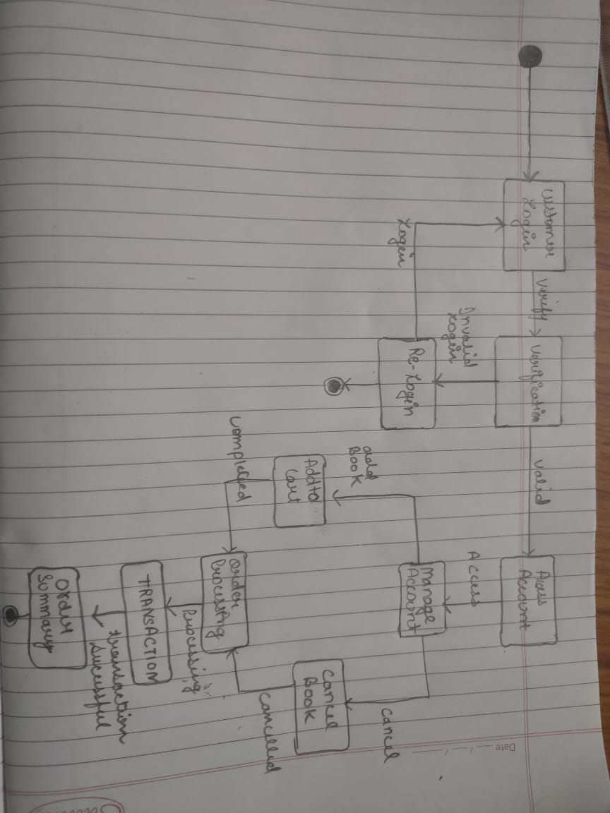

Sequence Diagram

In **software engineering**, a system **sequence diagram** (SSD) is a **sequence diagram** that shows, for a particular scenario of a use case, the events that external actors generate, their order, and possible inter-system events.

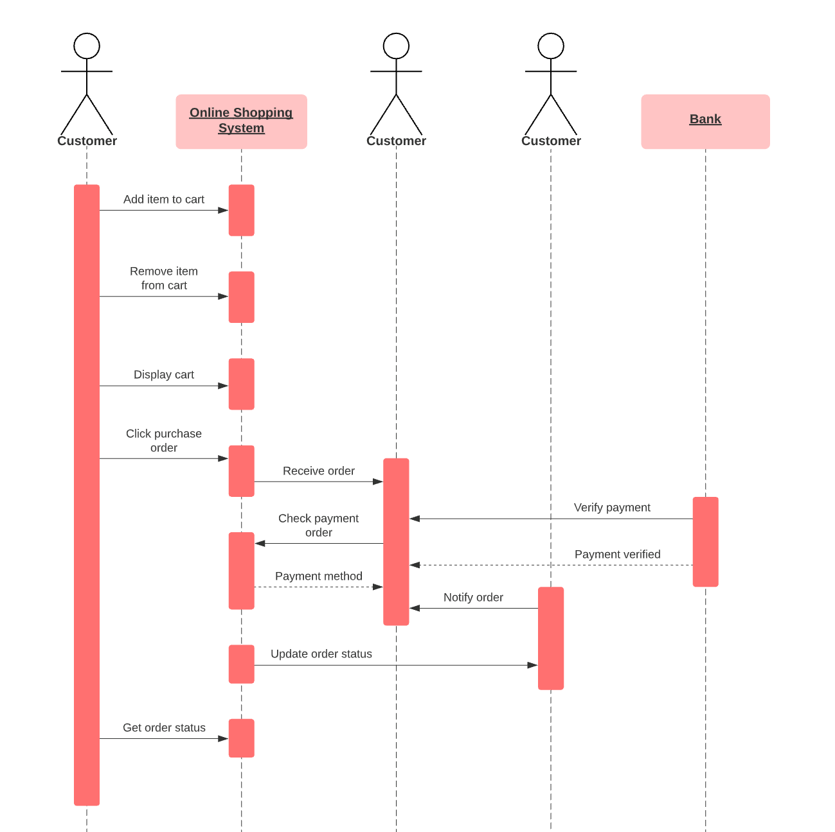

Abstract Views

MOB-MOD is an initiative to provide a customized and personalized smartphones to the customers.Coustomers can add all the nessecary parts according to thier need and desire in our development environment.The user needs to pay only for their utility parts and for needless features which may cost them high price unnecessarily.

The steps to use our services are:-

First login or signup incase you are new customer to our website.

After you are successfully logged in you either directly go into our customization zone where you can add customize you own smartphone or you can browse for any specific parts which is new into the market.

After you enter into our cutomization zone you can refer to our list of mandatory parts which is nessecary to have inorder to make a complete samrtphone.Here itself you add any latest technology in your smartphone according to your needs.

After you complete customizing your smartphone you can either place it into your cart or order directly.

You have to make a successfull payment inorder to recieve the product.

After we confirm your payment you will recieve you order and delivery summary.

We also provide a relaxation of two days after the final order is confirmed inorder to make any further changes.

Class Diagram

In **software engineering**, a **class diagram** in the Unified Modeling Language (UML) is a type of static structure **diagram** that describes the structure of a system by showing the system's **classes**, their attributes, operations (or methods), and the relationships among objects.

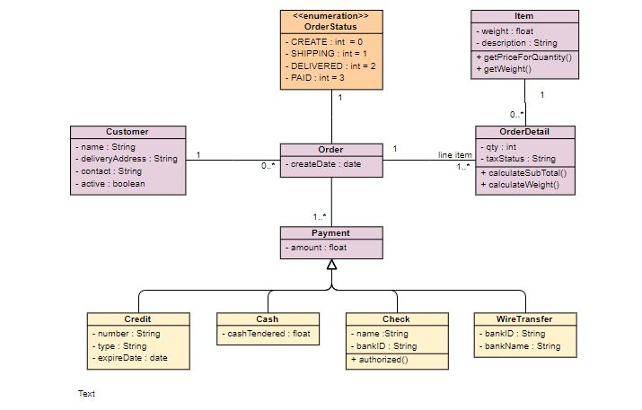

Use of Agile Methodology in Project

The methodology upon which the project is to be carried on in any organization totally depends upon the nature of the project. For our project we undertook “Agile Methodology”

which best suits our needs and demands.

Agile Methodology – Agile methodology is a practice that promotes continuous iteration of development and testing throughout the software development lifecycle of the project. Both development and testing activities are concurrent unlike the Waterfall model .

The agile software development emphasizes on four core values.

⦁ Individual and team interactions over processes and tools

⦁ Working software over comprehensive documentation

⦁ Customer collaboration over contract negotiation

⦁ Responding to change over following a plan

There are various steps which makes agile a complete methodology. Those steps as incorporated in our project are discussed below in detail.

1} Requirement and Analysis: The process of agile methodology starts with a detailed planning and discussion about the project. The project manager along with the project owner discuses the functionalities and features about the project. The project manager notes down all the features as demanded by the owner. The owner on the other hand holds the responsibility to acknowledge the manager completely about the project.

Our project manager made sure to question the user until the user was satisfied about our final plan. The final plan was then converted to the company project with the agreement of the user. We made sure that the website holds the efficient search algorithm, payment technique,and an efficient auto-suggestion according to the user.

2} Design: This step involves the initial architectural designing of the project. The final plan is set into smaller tasks. Each task is distributed among the project team according their respective areas of expertise. This is the stage where the team has to decide features which has to come under primary and secondary list. The team should the best interface which is easy to understand and does does not involves any unnecessary complex programs. The interface of the application of the program should be fast while loading and portable on sizes of the screens.

Our project is built in such a way that the user does not have to have a very speed internet. The API’s used are very fast in loading and easy to understand. The consumers do their payment very securely.

3} Development: This step involves the real coding and development of the application. The developer team is approached in order to assign them tasks. In this step the developer team and business end should be in continuous touch of each other. The developer must continuously present their progress to the users in order to take any preferable review for further changes.

The developer must first build the beta version of the application to upload it on any platform. The consumers can use that website and suggest any missing features which can improve the appearance and working of the application.

4}Quality Assurance: This step approves the Quality of the application build by the developer team. The Quality Assurer must know in advance the failures of the features in order to prevent it in advance from failing. The user should have no issue in near future after the release. The team should bring upon any changes which are not certified by the quality team.

5}Deployment: Agile deployment may be seen as simply another testing step since multiple development deployment are performed between production deployments. QA "users" are deeply involved in improving the system by providing frequent feedback. These are not system or organization-wide deployments. The code is deployed to a QA or testing environment that is accessible to specific users and as close as possible to a real-world environment. That way, users can continuously test the software and send it back for improvement. In some cases, patches may actually be added in the production environment. Or, the product may be sent back for more iterations in development. And, sometimes, pilot or beta deployment to a limited number of end users in the final environment may also be done for even greater insight into real-world usage.

6}Release to the market: The last and the final step is release into the market. The complete tested application is released into in many releases. Each release contains some additional features as compared to its previous release. The features are added according to the past experience and failures.

Our developer team would always strive for the betterment of the user. The team will always be ready for making any additional features in the future releases of the application. If the user wants an improved graphics, payment system or a self customization zone within the application. If the user wants they can design their own back covers for their smartphones in our future releases.